**Supplementary Material A:**

**Results of the eRm Analysis**

Following Linacre’s (in press) advice for Rasch analysis with R, a confirmatory analysis was conducted with the eRm package. This analysis involved the data set from the final iteration of the TAM analysis, which comprised responses to 92 items by 185 persons. The TAM-derived logits were reverse signed for ease of interpretability (i.e., the logit for *Tony* [-1.96] became 1.96, thus larger values represented *more familiar* according to the target group), and to match the direction of the eRm logits. In contrast to eRm, without this reversal, the logits produced by TAM are interpreted as ‘difficulty’ in accepting the item as familiar, whereby large number represent less familiarity for the target population. The TAM-derived logits displayed perfect correlation with the eRm-derived logits, *r* = 1.00 [1.00, 1.00]. Figure 1 presents boxplots comparing the SE, infit and outfit MNSQ, and *t* score statistics for the items produced with both packages. The SEs plotted in Figure 1a suggest that the precision of the logit estimates was practically identical between the two packages, while Figures 1b through 1e indicate the same for the item fit statistics. The person fit statistics calculated with eRm indicated that 13 persons underfit the expectations of the model, with outfit MNSQ values ranging between 1.50 to 2.82. The responses of the 13 participants were individually checked, and in all cases the misfit related to responses in the top-left and bottom-right corners of the Guttman map. This indicated that the eRm misfit statistics were perhaps more conservative than the TAM equivalents, and was most likely a relic of the different estimation methods utilized by the software, in which the person parameters are treated differently.

Figure 1

*Boxplots Illustrating Item (a) Standard Errors, (b) Infit Mean Squares, (c) Outfit Mean Squares, (d) Infit* t*, and (e) Outfit* t *Statistics by Software Package*

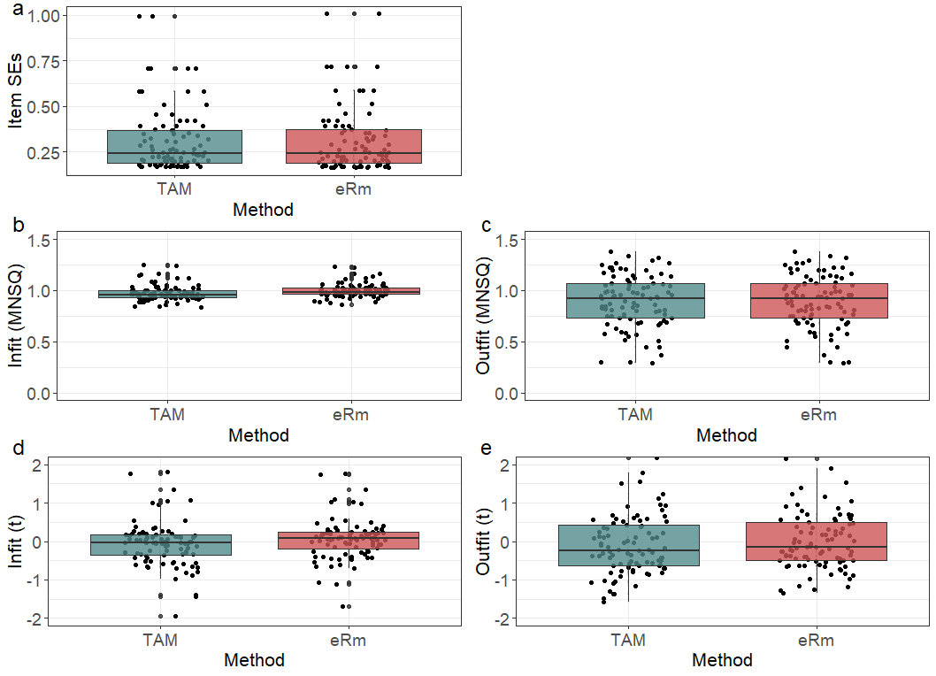

**References**

Linacre, J. M. (in press). Advancing the metrological agenda in the social sciences. In S. Cano, P. Marquis, A. Regnault, & W. P. Fisher Jr. (Eds*.), Person-Centered Outcome Metrology*. Springer.